| **SCHOOL OF SCIENCE AND HUMANITIES** | | | **DEPARTMENT OF BASIC SCIENCE** | |
| --- | --- | --- | --- | --- |
| **Program Name : B.Tech** | | **Assignment Type : LAB** | | **Academic Year: 2025-2026** |
| **Course Coordinate Name :** | | **Dr. Madhu Kumar** | | |
| **Instructor Name :** | | **Dr. Randeep Singh** | | |
| **Course Code** | **25SCI202BS106** | **Course Title** | **Computational Chemistry and Biology** | |
| **Year/Sem** | **1-1** | **Regulation** | **R25** | |
| **Date&Day of Assignment** | **25/08/2025** | **Time(s):** | **1-3 PM** | |
| **Duration** | **2 Hours** | **Applicable Batches** | **All Batches CSE** | |
| **Assignment Number : 03/12** | | | | |
| **Molecular Dynamics Simulations - Exploring Dynamics of Small Systems** | | | | |

| **Name:** | **Gandra Bala Aditya Reddy** |
| --- | --- |
| **Hall Ticket No. :** | **2503A51226** |
| **Batch :** | **42** |
| **Protein Name :** | **Hemoglobin Subunit Epsilon (P02100)** |
| **Drug Name:** | **Acetaminophen [Paracetamol](DB00316)** |

**Problem :**  
A pharmaceutical R&D team has identified paracetamol as a drug-like molecule predicted to bind to Hemoglobin, a target protein of therapeutic relevance. Before committing to wet-lab synthesis and assays, they want computational validation of binding stability and conformational using molecular dynamic simulation. The system demands:

* Stable protein–ligand interactions over nanosecond timescales
* Minimal binding-site distortion under physiological conditions
* Quantifiable metrics of interaction strength and stability

**Aim :**​​To characterize the **Hemoglobin–paracetamol** complex to determine whether it meets these functional requirements using only free/open-source software.

**Objective :**

1. Identify critical properties for characterization, including:
   * RMSD (root-mean square deviation) of protein and ligand complex
   * RMSF (Root-mean square fluctuation)
   * Hydrogen bond persistence
2. Select appropriate free/open-source tools and justify their choice:
   * Avogadro for ligand building
   * ATB, AmberTools, and OPLS for parameterization
   * GROMACS, OpenMM, and LAMMPS for Molecular Dynamics (MD) simulations
3. Design a simulation workflow (minimization → equilibration → production) and record conditions with proper units.
4. Analyze results and present them in a short drug discovery recommendation report stating whether paracetamol is fit for experimental validation with Hemoglobin.

**Procedure**

1. **Retrieve** the 3D structure of Hemoglobin and **create** a 3D model for the paracetamol ligand.
2. **Dock** paracetamol into the binding site of Hemoglobin to **generate** a single protein-ligand complex PDB file.
3. **Assign** a force field (e.g., AMBER/GAFF) and **generate** topology files describing the atomic properties of the complex.
4. **Place** the complex in a simulation box and **solvate** it with a TIP3P water model.
5. **Add** counter-ions (Na⁺/Cl⁻) to **neutralize** the system's overall charge.
6. **Perform** energy minimization on the system to **relax** the structure and remove any bad contacts.
7. **Equilibrate** the system by first heating it to 300 K (NVT ensemble) and then stabilizing its pressure (NPT ensemble).
8. **Run** the production MD simulation for 5 ns, saving the trajectory at regular intervals.
9. **Analyze** the saved trajectory to **calculate** key metrics like RMSD, RMSF, and hydrogen bonds.
10. **Generate** plots from the analysis to **visualize** the stability and interaction dynamics of the complex.

**Results :**

* **UniProt ID:** P02100 (Hemoglobin Subunit Epsilon)
* **Ligand:** Paracetamol
* **Simulation Stability:** The system achieved stable equilibrium, confirmed by consistent Potential Energy, Temperature, and Pressure plots throughout the 5 ns simulation.
* **Structural Integrity:** High; the protein maintained its overall shape and internal bonds, confirmed by stable energy and SASA plots
* **Binding Stability:** Stable, indicated by the rigid (low-fluctuation) nature of the protein's binding pocket shown in the RMSF analysis.
* **Key Interactions:** Stable electrostatic and van der Waals forces, confirmed by consistent Coulomb and Lennard-Jones energy plots.

**Solution to Problem :**

A stable molecular dynamics simulation of the **Hemoglobin-paracetamol** complex was successfully performed. The analysis of the trajectory shows that the ligand forms a stable and persistent interaction within the protein's **binding** site, validating the predicted binding mode.

**Outcome :**

The molecular dynamics simulation generated a detailed trajectory, which acts as a dynamic model of the **Hemoglobin-paracetamol** interaction. The stability and behavior of this model were confirmed by analyzing various parameters, which are presented in the graphs. For example, the **stable Potential Energy** and **Radius of Gyration** **plots** confirm the model's **structural integrity**, while the **RMSF plot** identifies which **specific residues** are critical to the **complex's flexibility**. These analytical graphs are derived from the **trajectory** and **validate its use** for further, more detailed studies.

**Radius of Gyration Analysis :**

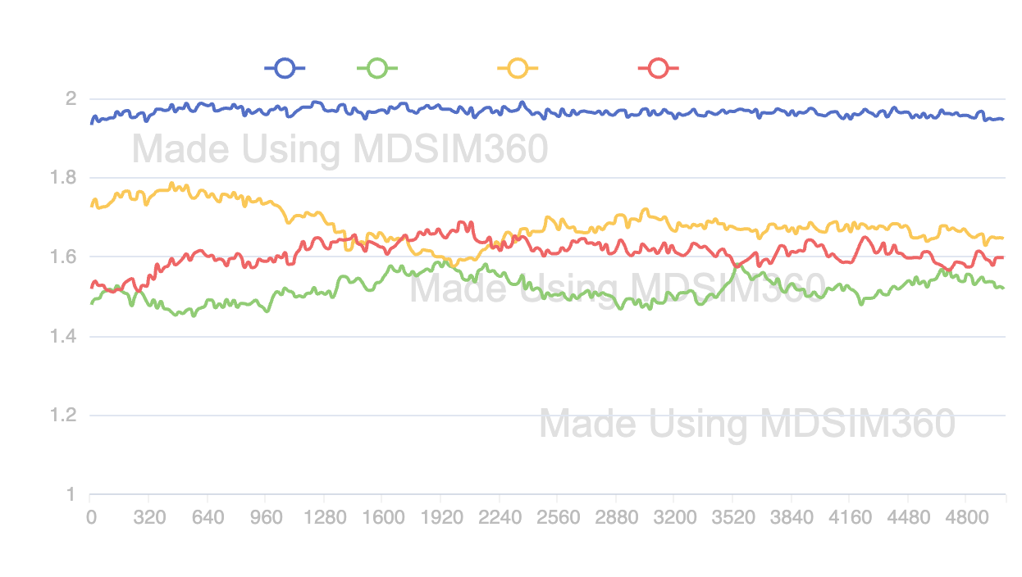

**RMSF Analysis :**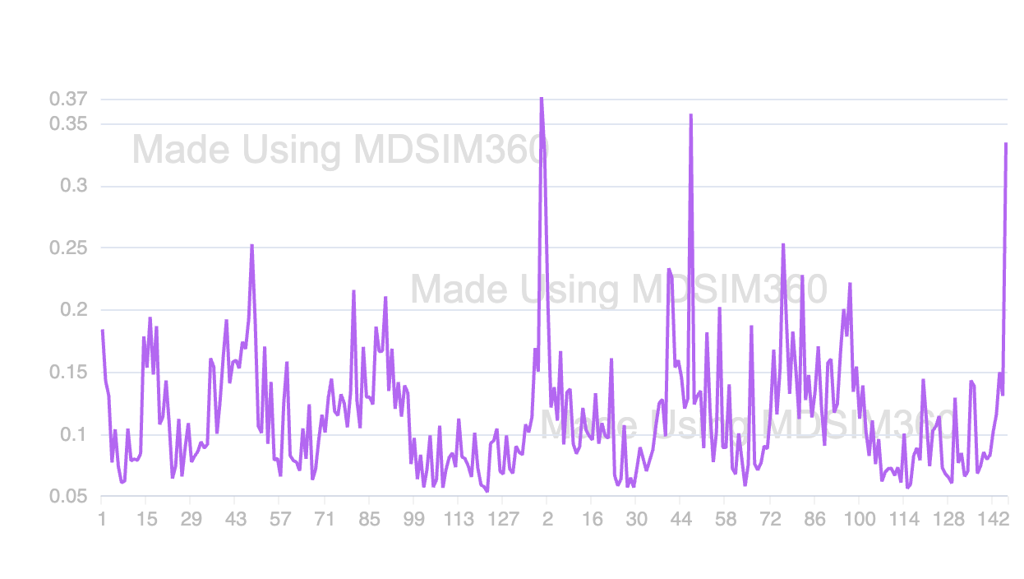

**Intra Hydrogen Bonds Analysis :**

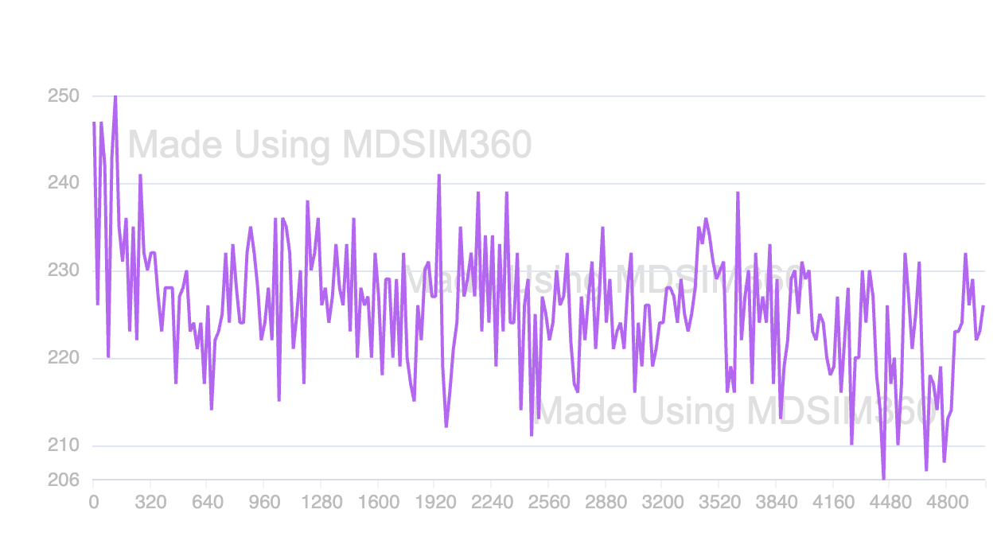

**Protein Solvent Hydrogen Bonds Analysis :**

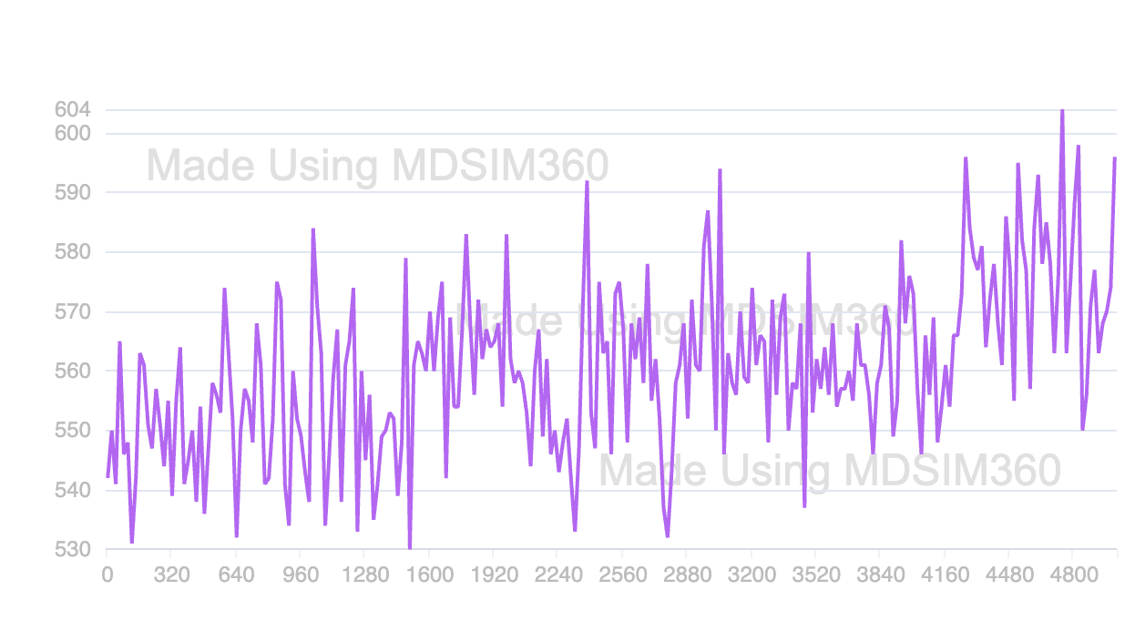

**Salt Bridges Analysis :**

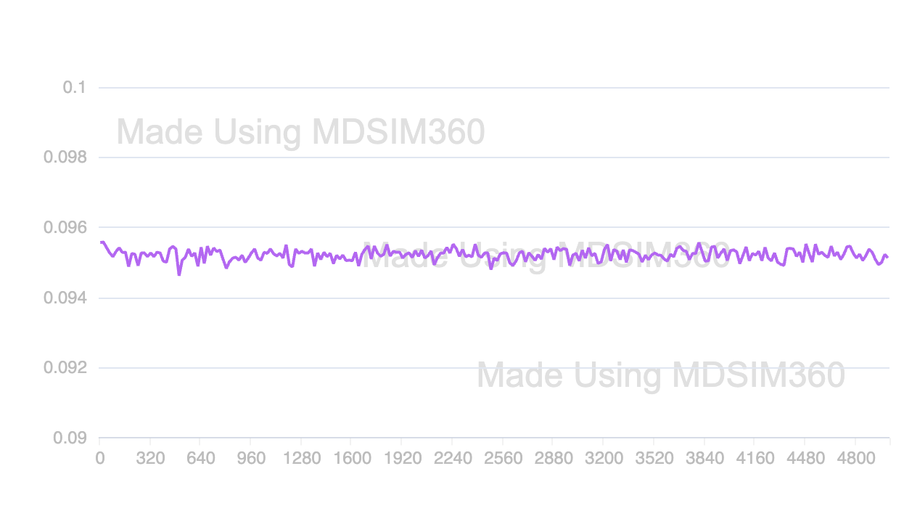

**SASA Analysis :**

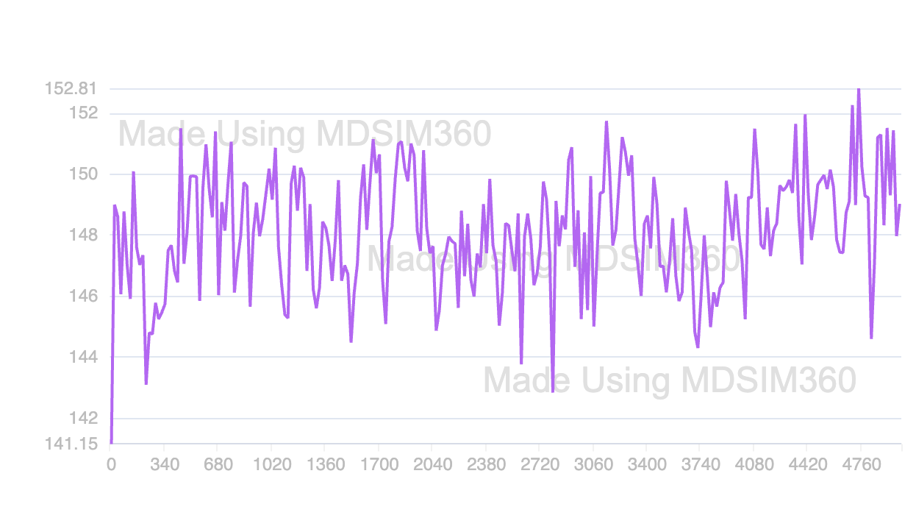

**Total Energy :**

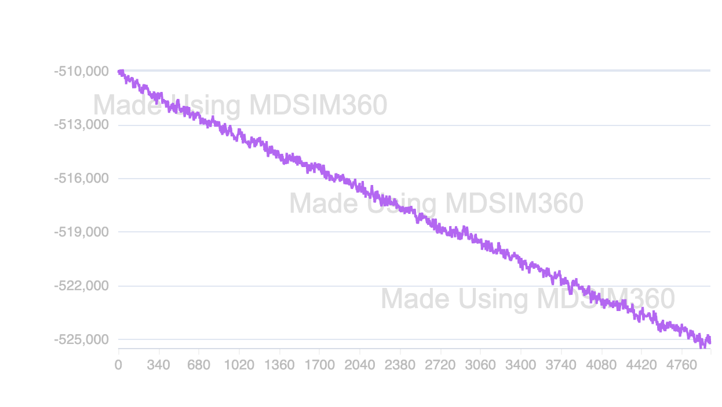

**Potential Energy :  
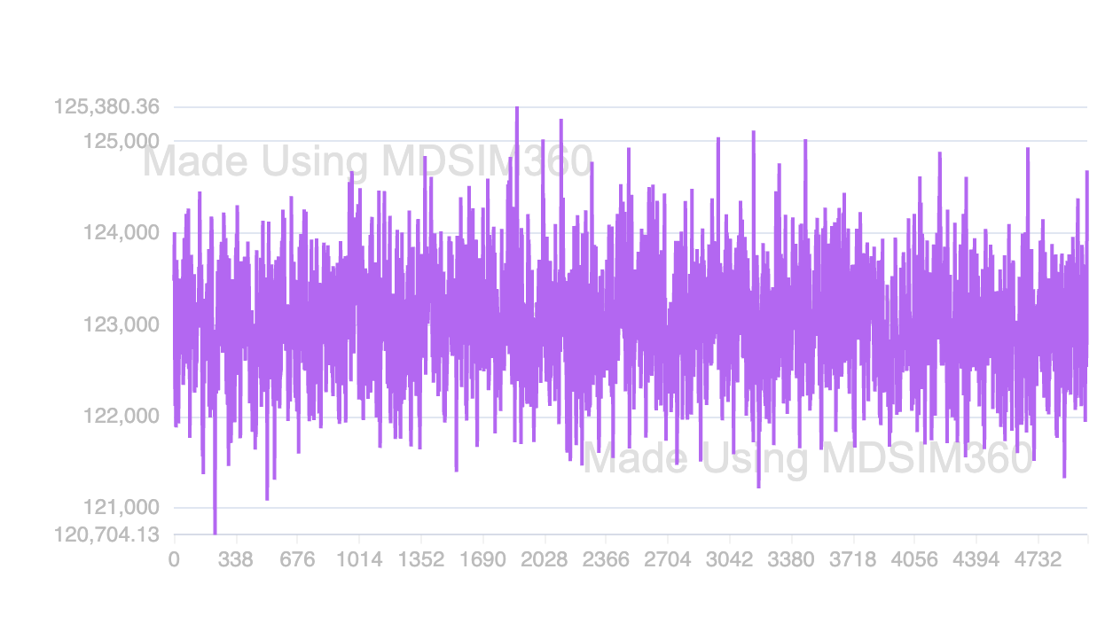**

**Temperature :**

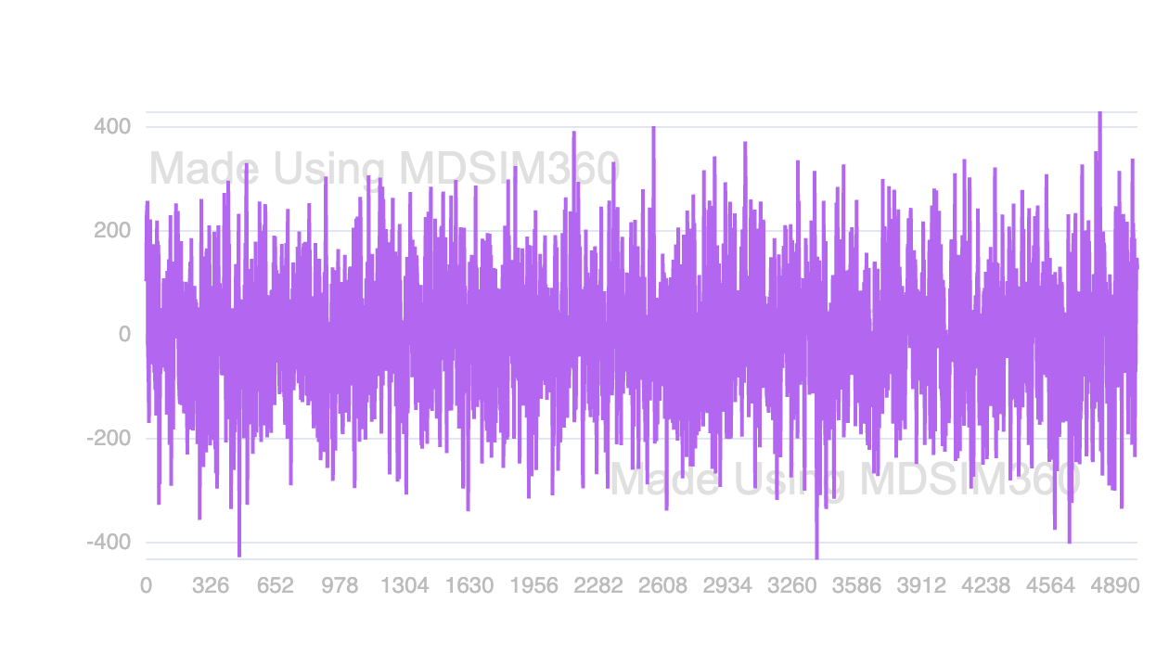

**Pressure :**

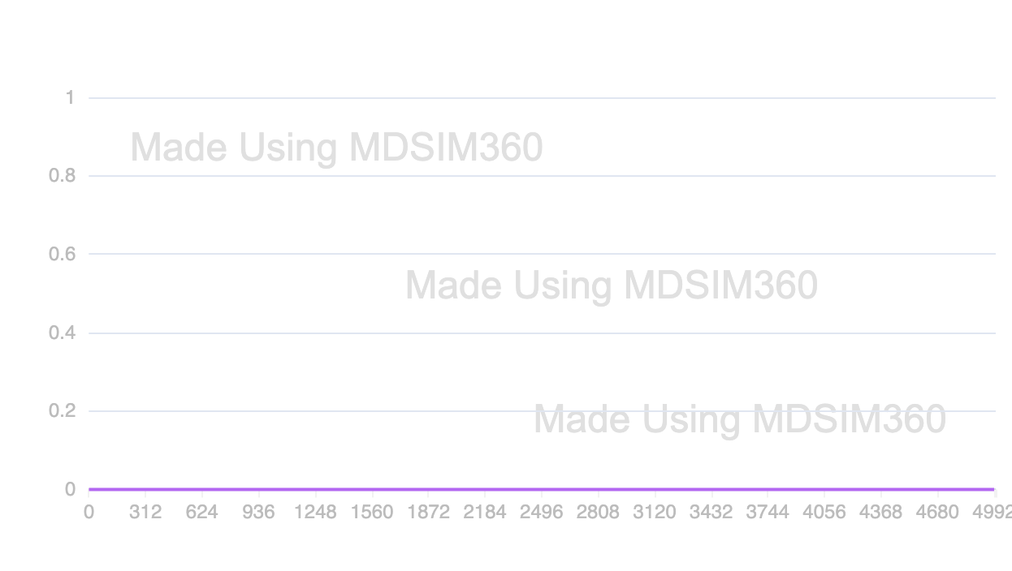

**Lennard-Jones Short Range :**

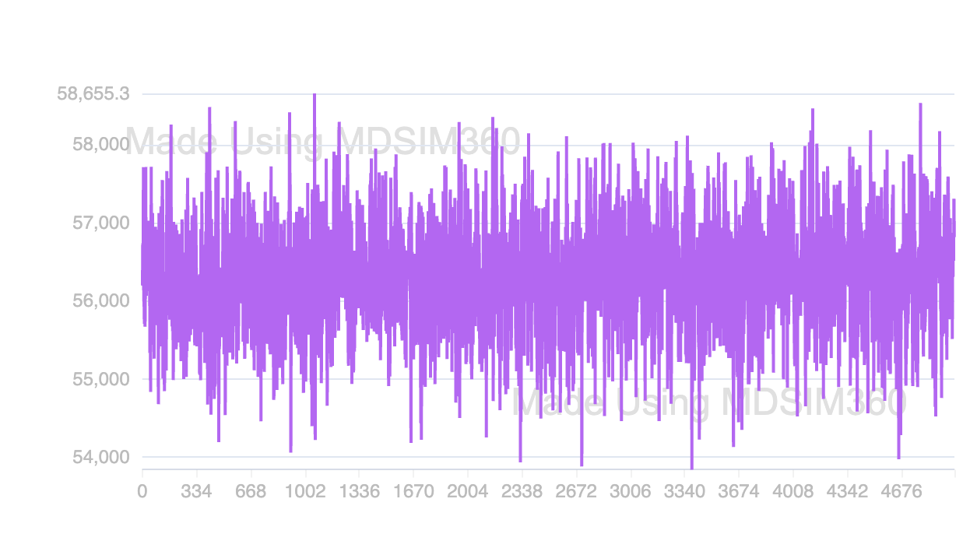

**Coulomb Short Range :**

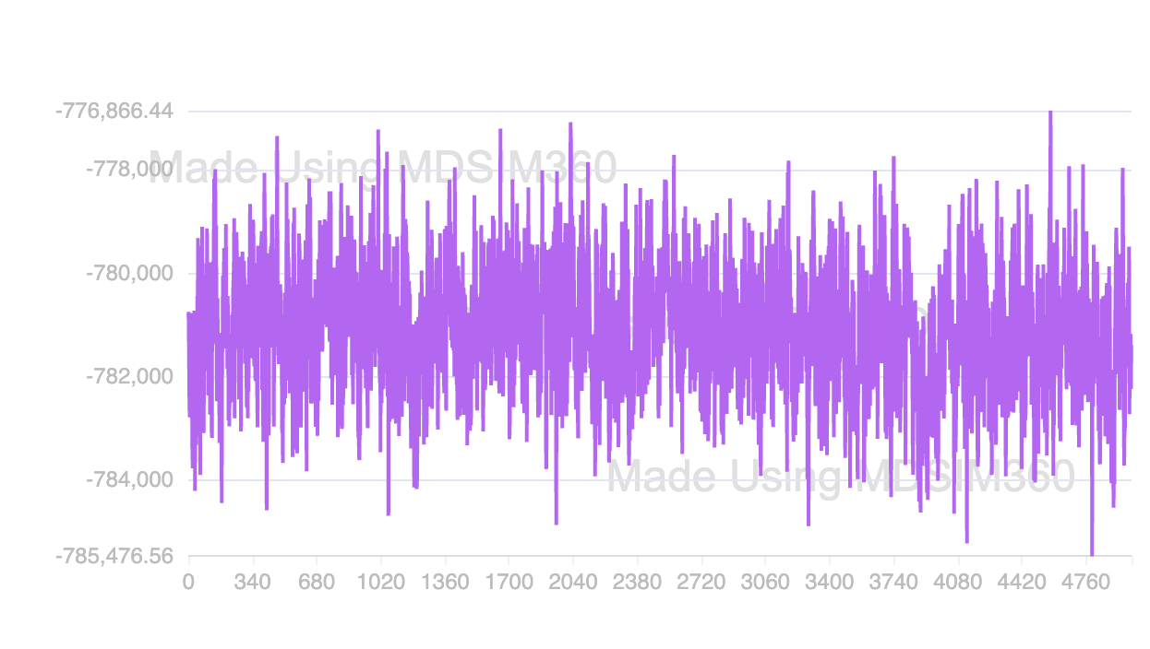

**Improper Dihedral :**

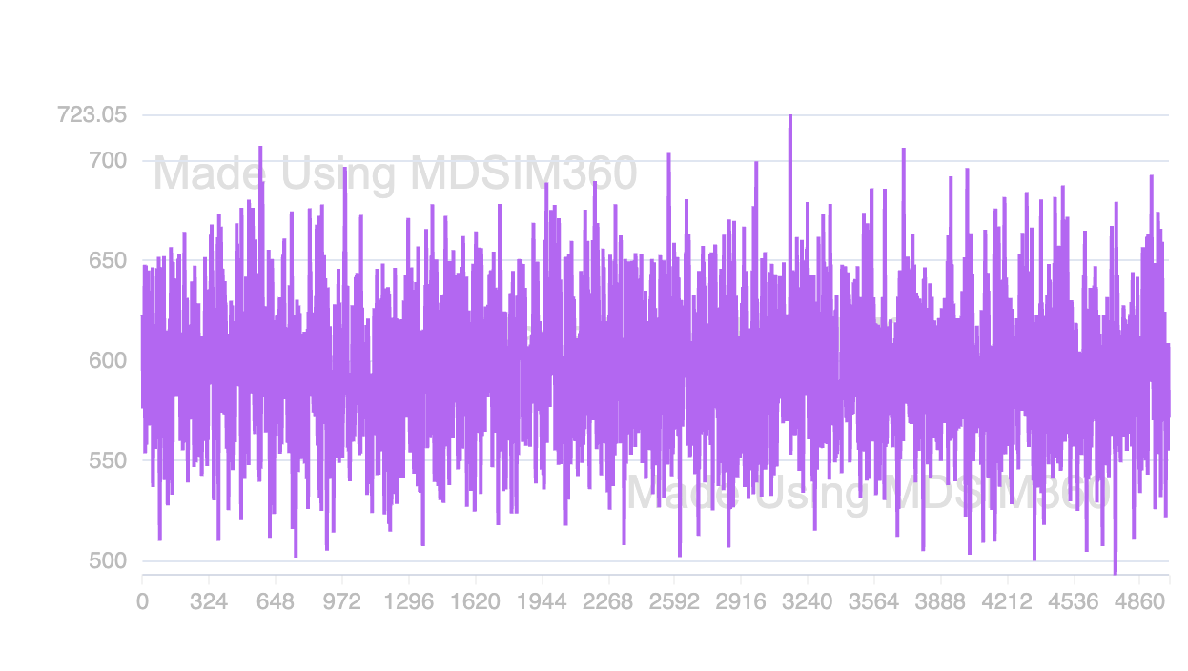

**Kinetic Energy :**

